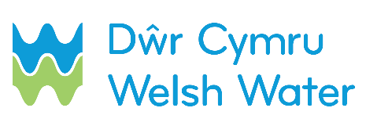

SLN 4_a – Request for DCWW to operate a valve to facilitate a back to back connection

This form must be filled and emailed to self.lay@dwrcymru.com. It should be used when DCWW is to connect up self-laid mains to the existing network and submitted 5 calendar days in advance of the date on which the self-laid mains are to be pressure tested and chlorinated.
SECTION 1 – Contact details

Scheme name: __________________________________________________________________
Self-lay Provider name (SLP): ______________________________________________________
Contact name: __________________________________________________________________
Contact telephone number (preferably mobile):_________________________________________
Date sent to DCWW: D D / M M / Y Y Y Y
SECTION 2 – Job number / Site address

Dwr Cymru Welsh Water Scheme Number
Site address: ___________________________________________________________________
_________________________________________ Postcode_____________________________

SECTION 3 – Customer(s) affected

Are there any Customers affected? Yes No

If Yes, please provide details:

Customer No.1

Customer No.2

Customer No.3

Customer No.4

Customer No.5

Customer No.6

Customer No.7

Customer No.8

Customer No.9

Customer No.10

SECTION 4 – Pressure testing, chlorination and connection date

Please specify the date when you intend:

To pressure test the mains: D D / M M / Y Y Y Y

To chlorinate the mains: D D / M M / Y Y Y Y

To require connection*: D D / M M / Y Y Y Y

*subject to successful sample results

