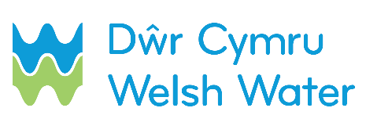

SLN 4_b – Notification of proposed routine (contestable)
mains connection

This form should be used by SLP and emailed to self.lay@dwrcymru.com to inform DCWW that they intend to make a routine (contestable) mains connections. It should be submitted 5 calendar days in advance of the date on which the self-laid mains are to be pressure tested and chlorinated.
SECTION 1 – Contact details

Scheme name: __________________________________________________________________
Self-lay Provider name (SLP): ______________________________________________________
Contact name: __________________________________________________________________
Contact telephone number (preferably mobile):_________________________________________
Date sent to DCWW: D D / M M / Y Y Y Y
SECTION 2 – Job number / Site address

Dwr Cymru Welsh Water Scheme Number
Site address: ___________________________________________________________________
_________________________________________ Postcode_____________________________

SECTION 3 – Pipe details

- Existing main:
Size: ____________________________ Material: ______________________________

- New main:
Size: ____________________________ Material: ______________________________
Proposed start date: D D / M M / Y Y Y Y

N.B.: Please enclose results

