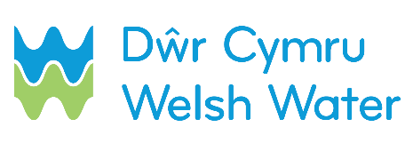

SLN 5_a – Notification of completed routine mains connection for self-lay scheme

This form should be returned to self.lay@dwrcymru.com within 24 hours of a routine mains connection having been made. It must be accompanied by as laids and filled in vesting certificate.
SECTION 1 – Contact details

Scheme name: __________________________________________________________________
Self-lay Provider name (SLP): ______________________________________________________
Contact name: __________________________________________________________________
Contact telephone number (preferably mobile):_________________________________________
Date sent to DCWW: D D / M M / Y Y Y Y
SECTION 2 – Job number / Site address

Dwr Cymru Welsh Water Scheme Number
Site address: ___________________________________________________________________
_________________________________________ Postcode_____________________________

SECTION 3 – Completed connection

*Please only complete this section if you successfully completed the connection.

You must attach a plan, showing the mains on this site, to this form.
Please clearly highlight the mains that were commissioned.

Tick to indicate that such a plan is attached.

Date and time connection was completed: D D / M M / Y Y Y Y At: : hrs

