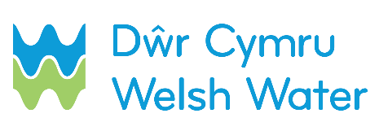

SLN 6 – Notification of commencement of water service connection for self-lay Scheme

DCWW reserve the right to carry out Water Regulation checks on the service you lay.
We require 10 working days and payment of connection in advance.
IMPORTANT: These dates are used to schedule DCWW water resources, therefore actual dates are required and not proposed dates or week commencing dates.

This form must be emailed to self.lay@dwrcymru.com, 10 calendar days prior to any service connection being carried out. Service connections can only be carried out if the connection charges for the plots listed below have been paid for in advance.
If payment has not been received the service connection will be refused.
Full postal addresses including the postcode must be given prior to connection being carried out.

SECTION 1 – Contact details

Scheme name: __________________________________________________________________
Self-lay Provider name (SLP): ______________________________________________________
Contact name: __________________________________________________________________
Contact telephone number (preferably mobile):_________________________________________
Date sent to DCWW: D D / D D / Y Y Y Y
SECTION 2 – Job number / Site address

Dwr Cymru Welsh Water Scheme Number
Site address: ___________________________________________________________________
_________________________________________ Postcode_____________________________

SECTION 3 – Commencement of Service laying

SECTION 4 – Connection dates

Please, print this sheet as many copies as you need

Page ____ of _____

 | Plot Number |  | Job Number |  | Postal Address including postcode | Commencement of Service Laying (DD/MM/YYYY)

