Date:
Dear Sir/Madam

Site:

PROPOSED TEMPORARY DRAINAGE COMMUNICATION TO PUBLIC SEWER

With regard to your recent enquiry relating to the temporary communication of flows from the above development to the public sewerage system, please find enclosed the relevant documents:

- Temporary Connection Application Form;
- Applicant Checklist;
- Manhole Detail Plan;
- Public Sewer Record;

Please Note that upon completion of the technical assessment of your proposal you will need to enter into an Agreement with us to ensure that the temporary connection is constructed in the agreed form, and subsequently the connection removed from the public sewerage system.

Yours faithfully,

Owain George
Lead Development Control Officer
Developer Services

.
DEVELOPMENT DETAILS
DCWW Reference
Your Reference
Address of Site/Premises
Facilities to be Connected
Location of Connection Point
FLOW TYPES
Type of Flows to be Communicated  Please be advised that separate applications will be required for each flow type to be communicated with the public sewer |  | This section of the form must be completed - Specify one flow type only & delete as necessary.
  Foul Water only | Surface Water only | Combined Connection
PROPOSED DATE OF CONNECTION
Proposed Date of Connection
Proposed Date of Disconnection
APPLICANT & CONTRACTOR DETAILS
Applicant Details
 |  | Postcode: |  |  | Tel:
Details of Contractor undertaking Physical Communication works to the Public Sewer
 |  | Postcode: |  |  | Tel:
Contractor’s Health & Safety Accreditation
DECLARATION
Upon Completion of the Agreement, I shall submit the Access to Assets (AF02 Form) to DCWW Waste Operations* then give at least 48 hours’ notice (excluding weekends and official public holidays) to: Dŵr Cymru Welsh Water on 0800 917 2652 before commencing work, to allow their representative to superintend the work.

To pay for the cost of the inspection (costs to be Confirmed on processing of legal agreement).

Signed |  |  | Date:
TEMPORARY CONNECTION PLAN
DCWW Reference:
Your Reference:
Location of Connection Point:
DCWW Manhole Reference Number:
Plan |  |  | Section
Example Plan |  |  | Example Section
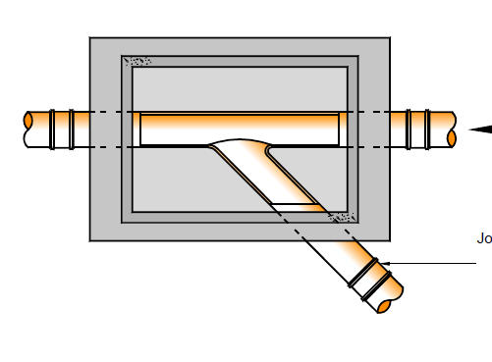 |  |  | 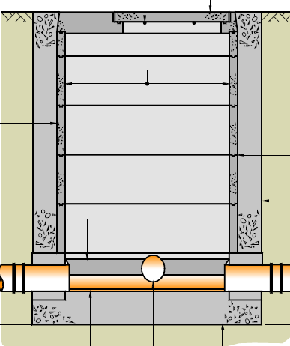

APPLICANT’S CHECKLIST
DCWW Reference:
Your Reference:
Completed Temporary Connection Application Form
Health Safety Approved Contractor, Approving Organisation Registration Details etc.
Fee
Copy of Planning Application form
Copy of Planning Permission (including evidence of discharge of any pre-commencement conditions relating to drainage)
Copy of Public Sewer Record (indicating property and route of drain connecting to Public Sewer)
Manhole Connection Plan and Section
Land registry title deeds covering the location of the proposed manhole

