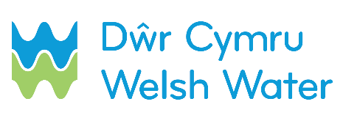

SLN 2 – Provision of supply for pressure and bacteriological testing for self-lay scheme

This form must be filled and emailed to self.lay@dwrcymru.com notifying us that you require a source of water for pressure and bacteriological testing.
Please be aware that this request may take up to 28 days from the date of receipt.
SECTION 1 – Contact details

Scheme name: _________________________________________________________________
Self-lay Provider name (SLP): ______________________________________________________
Contact name: __________________________________________________________________
Contact telephone number (preferably mobile):_________________________________________
Date sent to DCWW: D D / M M / Y Y Y Y

SECTION 2 – Job number / Site address

Dwr Cymru Welsh Water Scheme Number
Site address: ___________________________________________________________________
_________________________________________ Postcode_____________________________

SECTION 3 – Date of source of water

Please provide the date source of water is required D D / M M / Y Y Y Y

If known, please provide the date when a permanent connection is required

D D / M M / Y Y Y Y
SECTION 4 – Date of pre start meeting

Please provide the date of pre start meeting D D / M M / Y Y Y Y

SECTION 5a – Pressure testing, chlorination and sampling (by SLP)

If you are planning to do your own chlorination and sampling, please send us the certificates or/and complete below.

Please specify the date when you intend:

To pressure test the mains: D D / M M / Y Y Y Y

To chlorinate the mains: D D / M M / Y Y Y Y

To require connection*: D D / M M / Y Y Y Y

*subject to successful sample results

SECTION 5b – Pressure testing, chlorination and sampling (by DCWW)

If you require DCWW to do sampling, please complete the form SLN2_Annex1 for sampling request.

